User Interface Screenshots Report
Humanova: AI Hallucination Detection & Verification System
Course Information
Course Code | CSE 4204
Course Title | Mobile Computing Lab
Assignment | Week 07 – Frontend Development & API Integration
Team ID | CSE4204-8C-T07
Section | 8C
Team Members
Name | Student ID | Role
MD Robayet Hassan Rupom | 11220320979 | Frontend Developer & Team Leader
Bushra Monzur Moumi | 11220321048 | AI Integration Lead
Aqib Jawwad Nahin | 11220320969 | Backend Developer & Database Manager
GitHub Repository: https://github.com/Rupom090/CSE4204-8C-T07-Humanova
This document showcases the user interface screens of the Humanova AI Hallucination Detection & Verification system, demonstrating the visual style, layout structure, and design system implementation. These screenshots verify that the frontend components closely align with the approved UI/UX designs and reflect successful integration with the backend APIs.

Screenshot 01 — Landing / Home Page
Purpose | Introduces the Humanova system to public visitors, outlines core fact-checking benefits, and provides navigation to authentication gateways.
Key UI Components | Responsive Navigation bar, Hero section with interactive call-to-actions, features grid layout, platform stats counter, and footer links.
Backend API Mappings | Public content, does not require active session tokens.
Interface Capture:
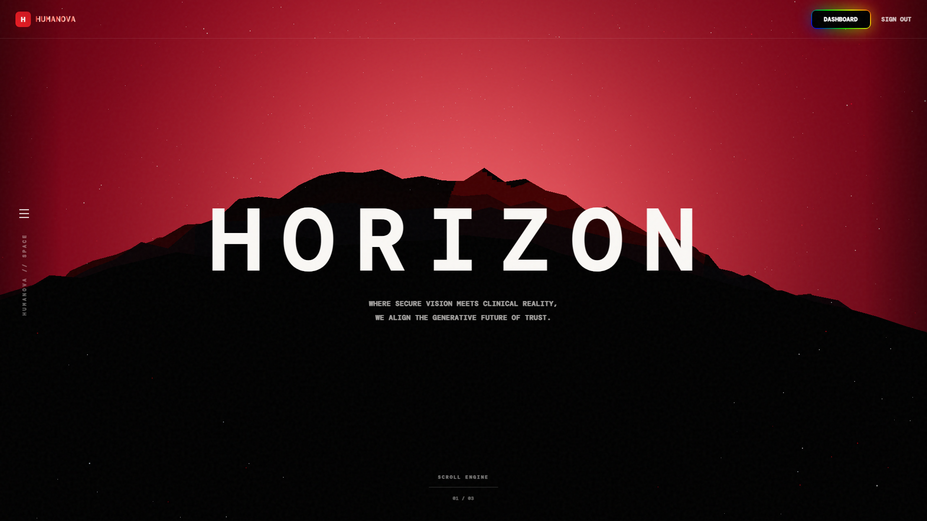
Figure 01.1: Landing / Home Page Interface Screen

Screenshot 02 — Login Page
Purpose | Permits registered users to authenticate, verify active accounts, and gain access to protected console features.
Key UI Components | Email input validation, password secure field, remember-me checkmark, login trigger button, and navigation triggers for registration or password recovery.
Backend API Mappings | POST /api/auth/login (JWT authentication endpoints).
Interface Capture:
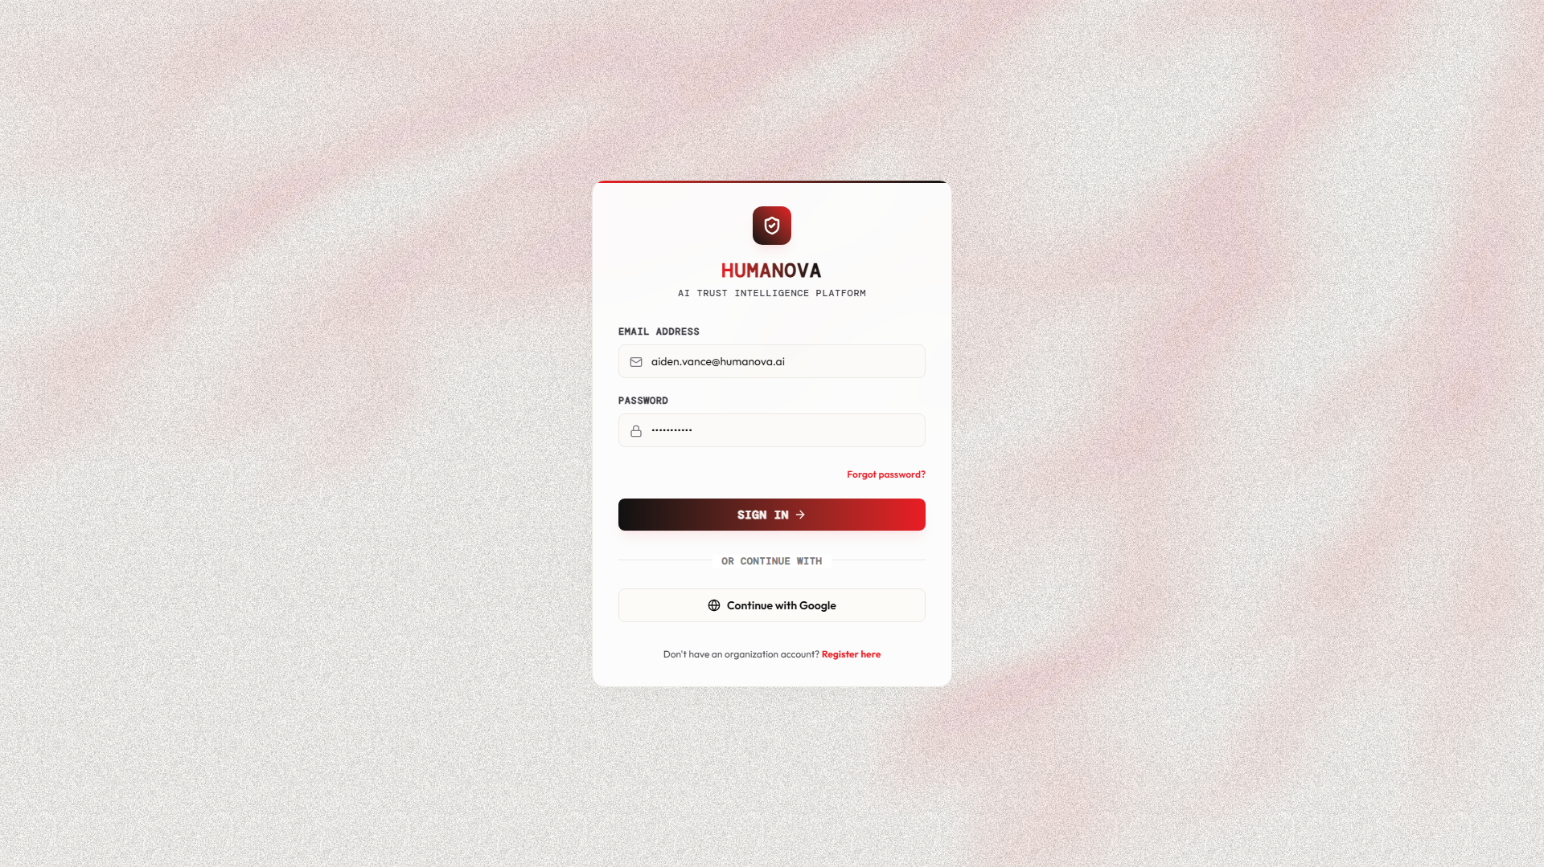
Figure 02.1: Login Page Interface Screen

Screenshot 03 — Registration Page
Purpose | Enables new users to create accounts on the platform.
Key UI Components | Full name validation field, corporate email validation, password strength checker, confirm-password field, and links to terms of service.
Backend API Mappings | POST /api/auth/register (Account onboarding endpoints).
Interface Capture:
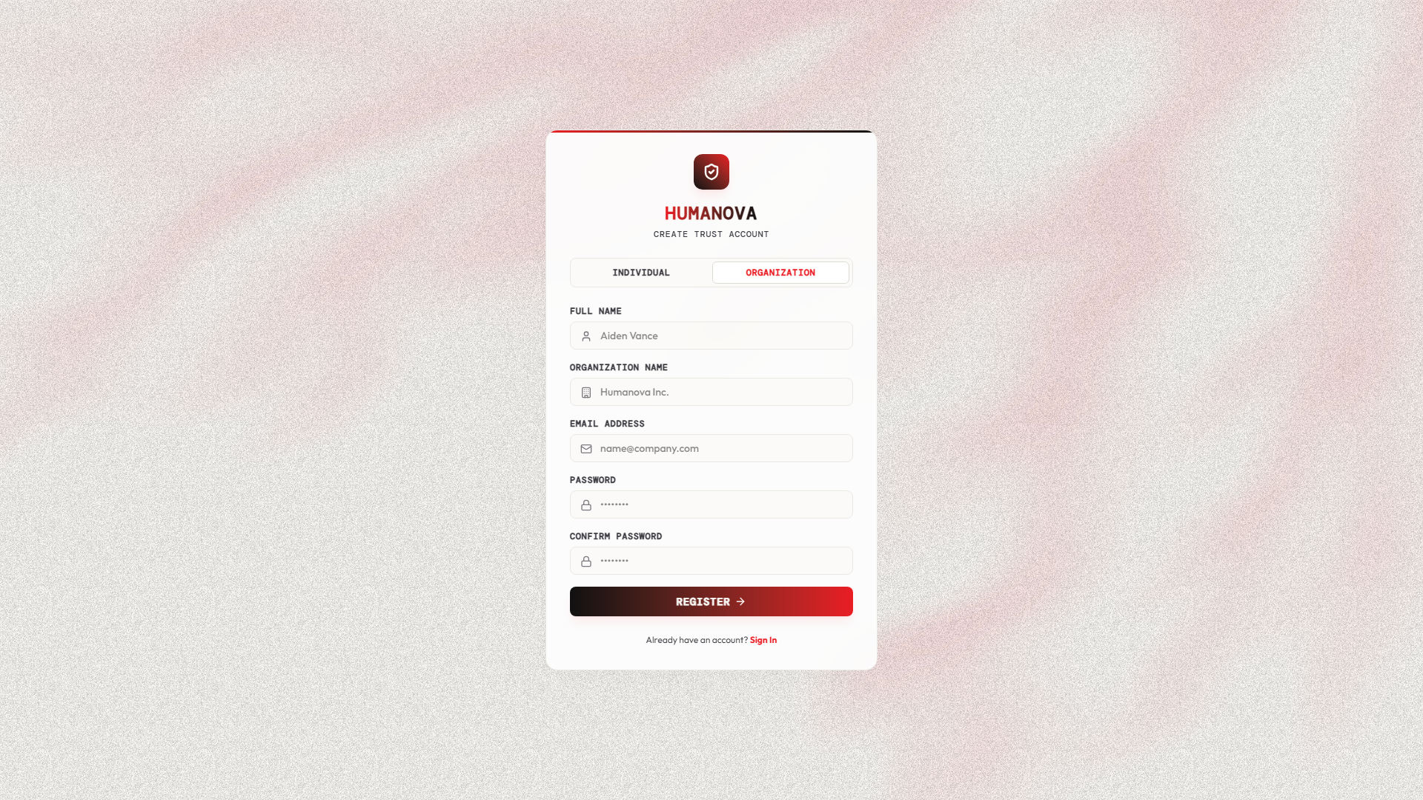
Figure 03.1: Registration Page Interface Screen

Screenshot 04 — Dashboard
Purpose | Serves as the central console for authenticated users, displaying system statistics, recent activity lists, and shortcuts.
Key UI Components | Verification counters (totals, flagged, verified), live facts check trends (area charts), navigation sidebar shell, and quick action tiles.
Backend API Mappings | GET /api/dashboard/stats, GET /api/scans/recent.
Interface Capture:
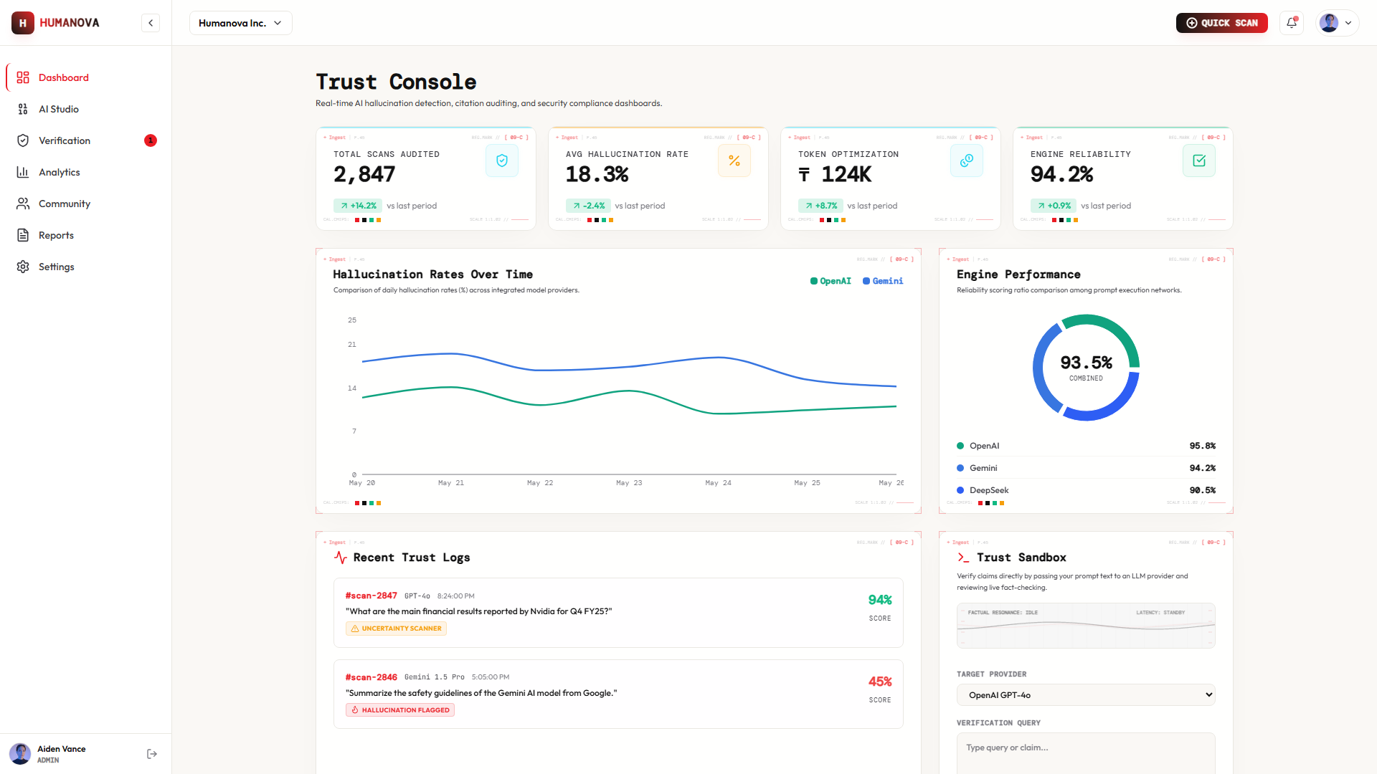
Figure 04.1: Dashboard Interface Screen

Screenshot 05 — Reports Page
Purpose | Allows users to explore generated verification documents, filter scan database logs, and trigger file exports.
Key UI Components | Reports list, document metadata, search parameters, sorting filters, and PDF export buttons.
Backend API Mappings | GET /api/reports, GET /api/reports/{id}/export (PDF dispatch routing).
Interface Capture:
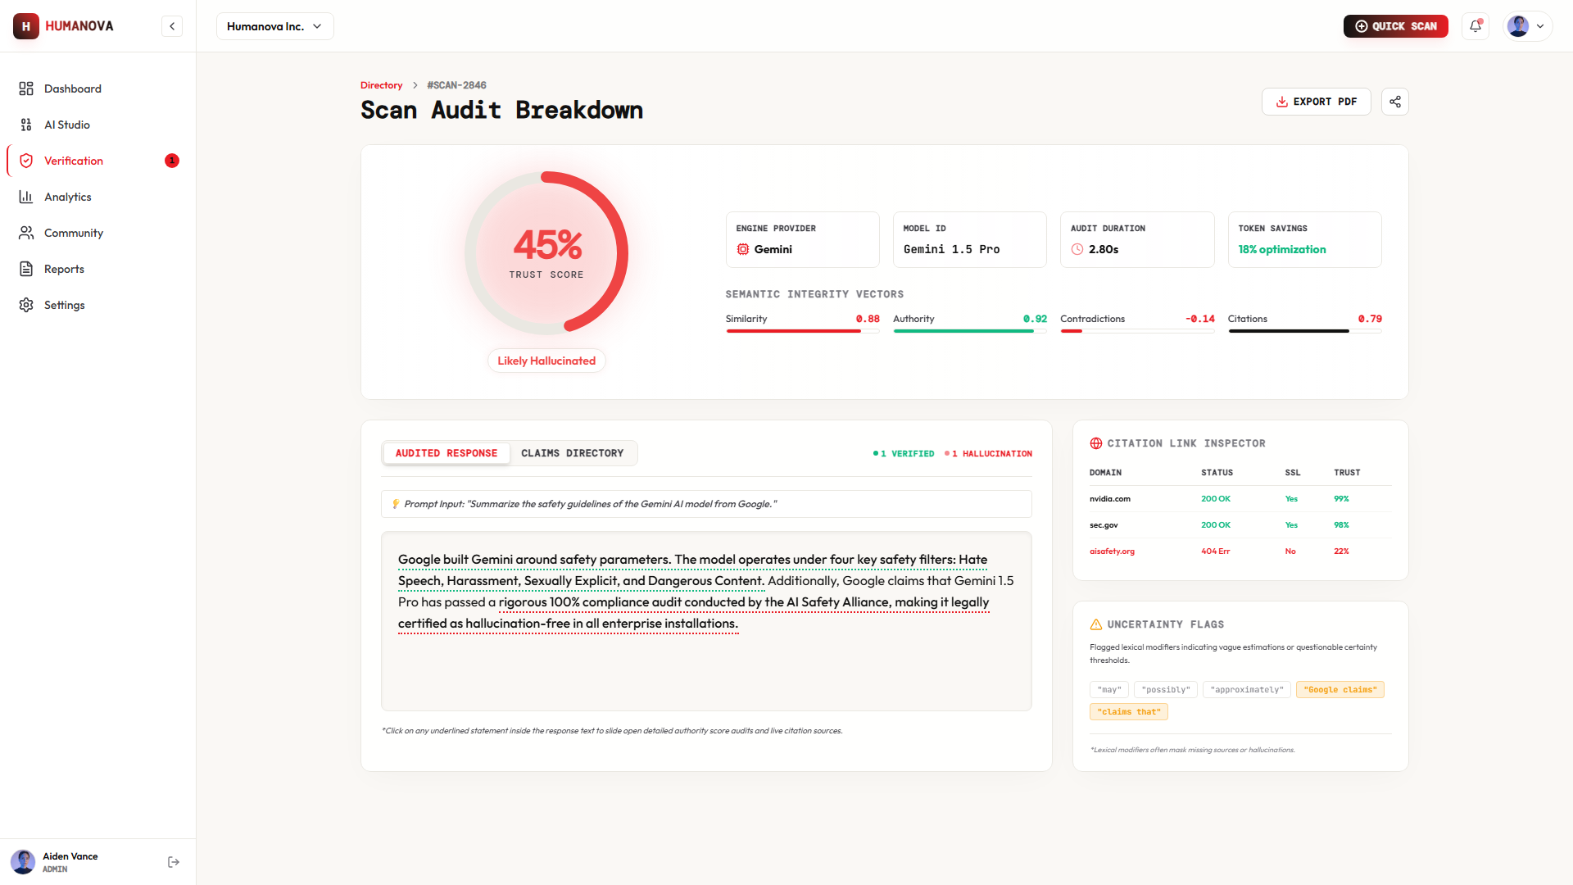
Figure 05.1: Reports Page Interface Screen

Screenshot 06 — User Profile Page
Purpose | Allows users to review, edit, and update account details, change passwords, and configure profile parameters.
Key UI Components | Personal details fields, password edit section, profile picture uploader, and active sessions tracker.
Backend API Mappings | GET /api/user/profile, PUT /api/user/profile/update.
Interface Capture:
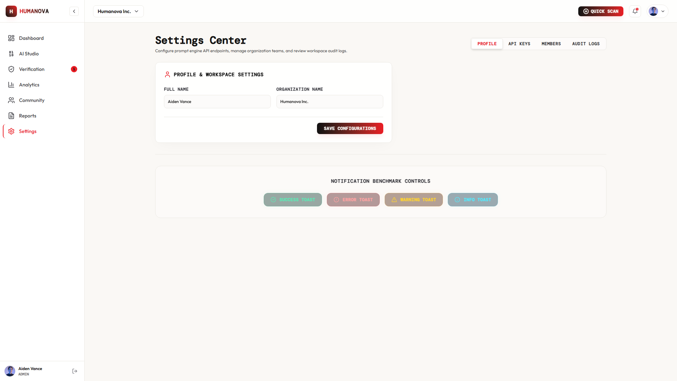
Figure 06.1: User Profile Page Interface Screen

Screenshot 07 — Settings & API Key Management Page
Purpose | Allows developers to generate, copy, and revoke API access keys for integration.
Key UI Components | Active keys list table, 'Create New Key' modal trigger, token permissions config, and copy-to-clipboard elements.
Backend API Mappings | GET /api/settings/keys, POST /api/settings/keys/generate.
Interface Capture:
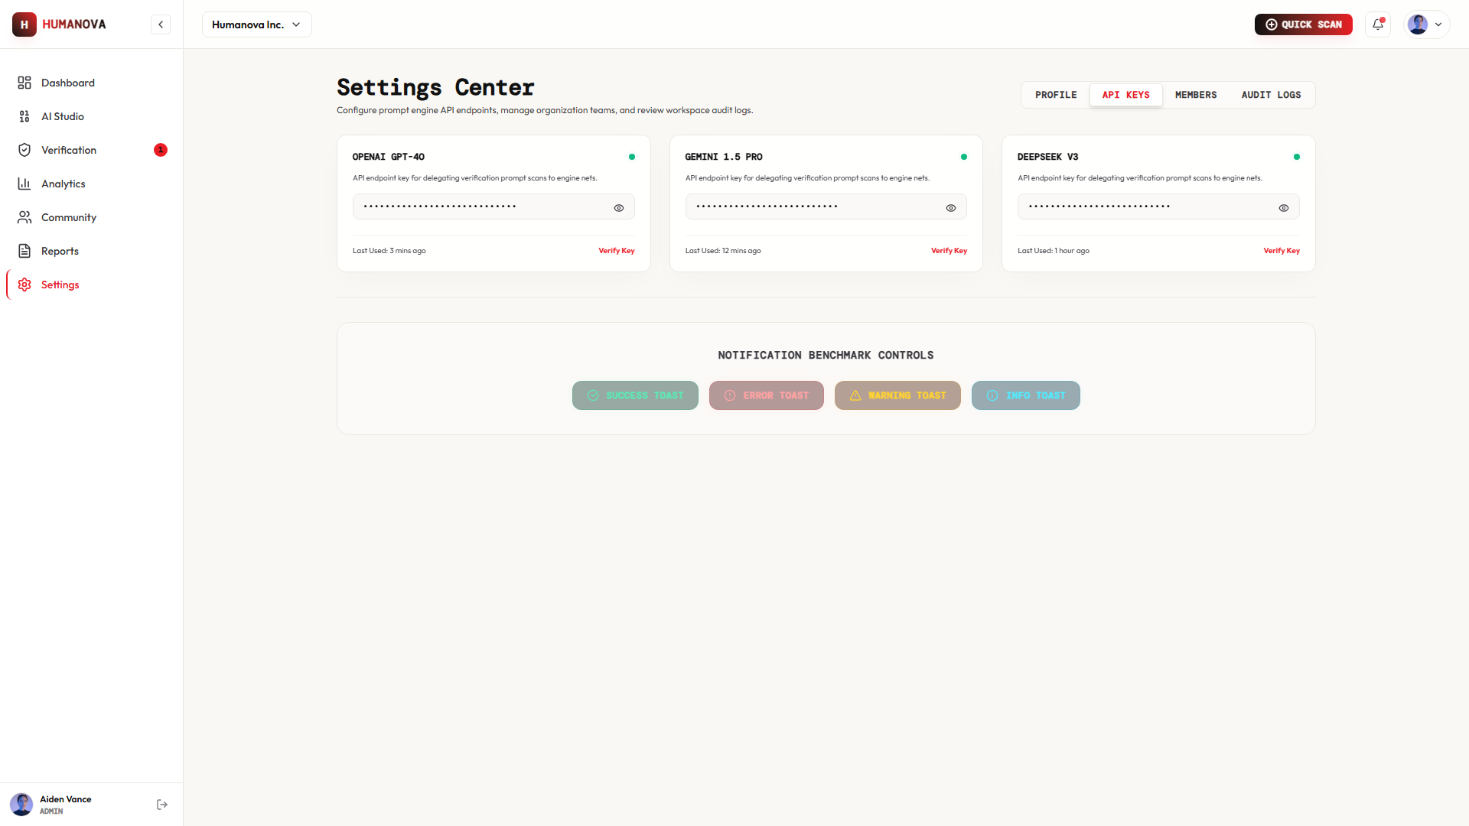
Figure 07.1: Settings & API Key Management Page Interface Screen

Screenshot 08 — Organization Management Page
Purpose | Allows workspace administrators to manage organization profiles, invite users, and update member privileges.
Key UI Components | Organization details form, members list table, email invite validator, and member role assignment dropdowns.
Backend API Mappings | GET /api/org/details, POST /api/org/members/invite, PUT /api/org/members/{id}/role.
Interface Capture:
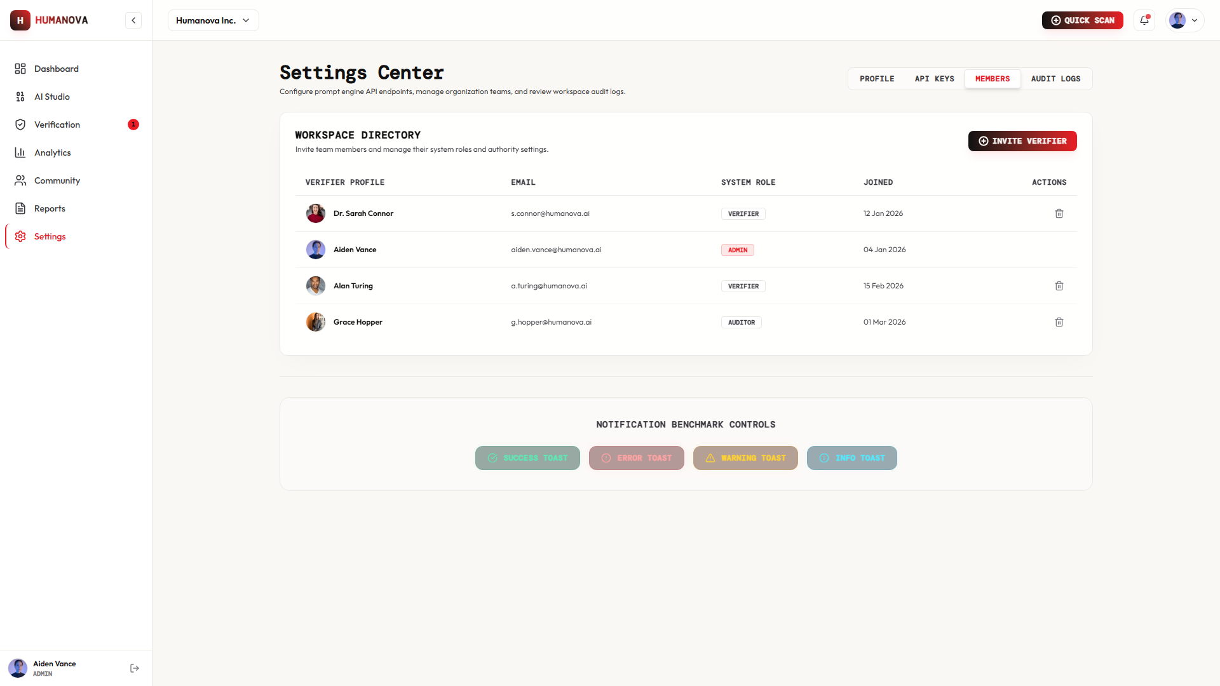
Figure 08.1: Organization Management Page Interface Screen

Screenshot 09 — Admin Panel
Purpose | Allows platform administrators to monitor usage metrics, verify active system states, and audit logs.
Key UI Components | Active system load graphs, user count monitors, endpoint frequency gauges, tenant records, and security audit logs table.
Backend API Mappings | GET /api/admin/metrics, GET /api/admin/users, GET /api/admin/audit-logs.
Interface Capture:
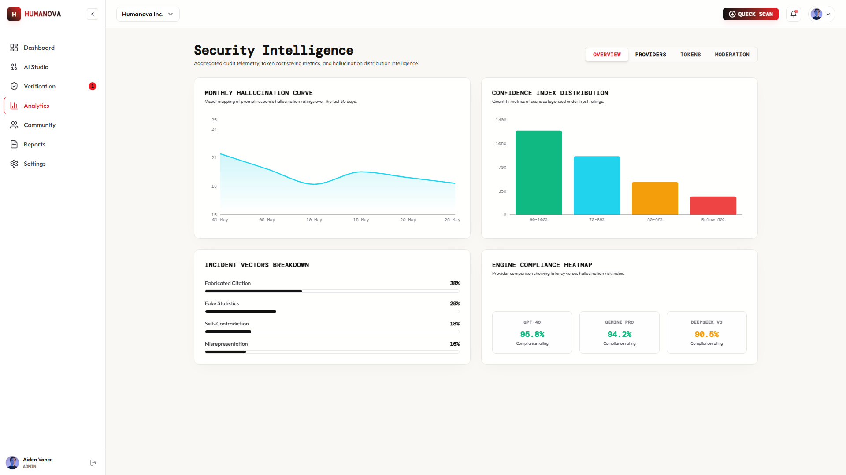
Figure 09.1: Admin Panel Interface Screen
Conclusion
The screenshots contained in this report illustrate the successful execution of the frontend interfaces for Humanova. The visuals confirm that spacing, color parameters, styling utilities, navigation controllers, dynamic dashboards, and organization management views comply with design standards and are functional, communicating directly with Laravel controllers.

